**WEEK 4**

**Spring REST using Spring Boot 3**

**1.Create a Spring Web Project using Maven:**

**Code:**

**SpringlearnApplication.java:**

package com.cognizant.springlearn;

import org.springframework.boot.SpringApplication;

import org.springframework.boot.autoconfigure.SpringBootApplication;

@SpringBootApplication

public class SpringLearnApplication {

public static void main(String[] args) {

SpringApplication.run(SpringLearnApplication.class, args);

}

}

**SpringlearnApplicationTest.java:**

package com.cognizant.springlearn;

import org.junit.jupiter.api.Test;

import org.springframework.boot.test.context.SpringBootTest;

@SpringBootTest

class SpringLearnApplicationTests {

@Test

void contextLoads() {

}

}

**Output:**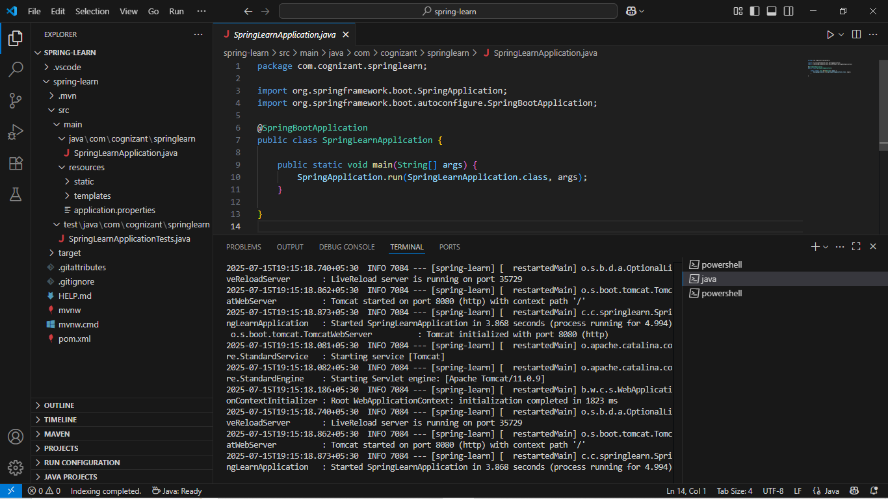

**2.Spring Core – Load Country from Spring Configuration XML**

**Code:**

**Country.java:**

package com.cognizant.springlearn;

public class Country {

private String code;

private String name;

public String getCode() {

return code;

}

public void setCode(String code) {

this.code = code;

}

public String getName() {

return name;

}

public void setName(String name) {

this.name = name;

}

@Override

public String toString() {

return "Country [code=" + code + ", name=" + name + "]";

}

}

**SpringLearnApplication.java:**

package com.cognizant.springlearn;

import org.springframework.context.ApplicationContext;

import org.springframework.context.support.ClassPathXmlApplicationContext;

import org.springframework.boot.autoconfigure.SpringBootApplication;

@SpringBootApplication

public class SpringLearnApplication {

public static void main(String[] args) {

ApplicationContext context = new ClassPathXmlApplicationContext("country.xml");

Country country = (Country) context.getBean("country");

System.out.println(country); // Expected Output

}

}

**country.xml:**

<?xml version="1.0" encoding="UTF-8"?>

<beans xmlns="http://www.springframework.org/schema/beans"

xmlns:xsi="http://www.w3.org/2001/XMLSchema-instance"

xsi:schemaLocation="

http://www.springframework.org/schema/beans

http://www.springframework.org/schema/beans/spring-beans.xsd">

<bean id="country" class="com.cognizant.springlearn.Country">

<property name="code" value="IN"/>

<property name="name" value="India"/>

</bean>

</beans>

**pom.xml:**

<project xmlns="http://maven.apache.org/POM/4.0.0"

xmlns:xsi="http://www.w3.org/2001/XMLSchema-instance"

xsi:schemaLocation="http://maven.apache.org/POM/4.0.0

https://maven.apache.org/xsd/maven-4.0.0.xsd">

<modelVersion>4.0.0</modelVersion>

<parent>

<groupId>org.springframework.boot</groupId>

<artifactId>spring-boot-starter-parent</artifactId>

<version>2.7.18</version>

<relativePath/>

</parent>

<groupId>com.cognizant</groupId>

<artifactId>spring-learn</artifactId>

<version>0.0.1-SNAPSHOT</version>

<packaging>jar</packaging>

<name>spring-learn</name>

<description>Spring Learn Application</description>

<properties>

<java.version>17</java.version>

</properties>

<dependencies>

<dependency>

<groupId>org.springframework.boot</groupId>

<artifactId>spring-boot-starter-web</artifactId>

</dependency>

<dependency>

<groupId>org.springframework.boot</groupId>

<artifactId>spring-boot-devtools</artifactId>

<scope>runtime</scope>

<optional>true</optional>

</dependency>

<dependency>

<groupId>org.springframework.boot</groupId>

<artifactId>spring-boot-starter-test</artifactId>

<scope>test</scope>

</dependency>

</dependencies>

<build>

<plugins>

<plugin>

<groupId>org.springframework.boot</groupId>

<artifactId>spring-boot-maven-plugin</artifactId>

</plugin>

</plugins>

</build>

</project>

**Output:**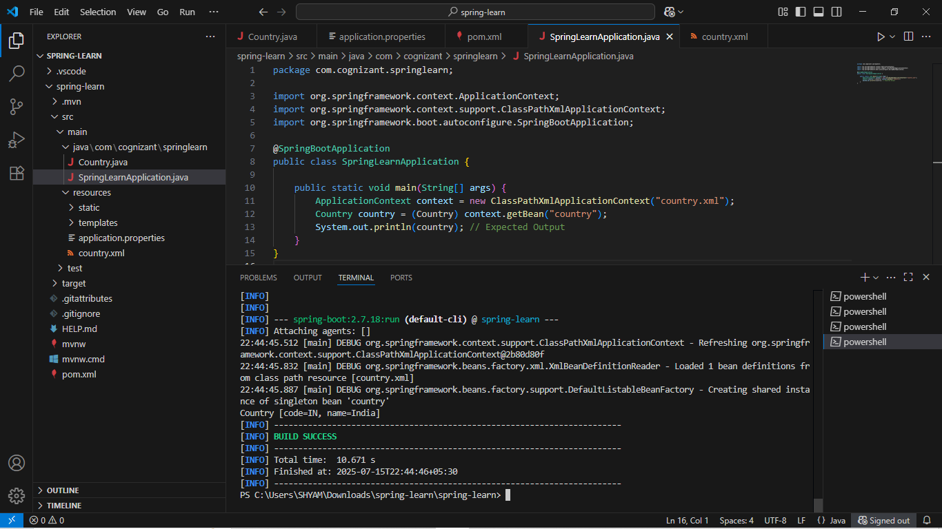

**3.Hello World RESTful Web Service:**

**Code:**

**HelloController.java:**

package com.cognizant.springlearn.controller;

import org.slf4j.Logger;

import org.slf4j.LoggerFactory;

import org.springframework.web.bind.annotation.GetMapping;

import org.springframework.web.bind.annotation.RestController;

@RestController

public class HelloController {

private static final Logger LOGGER = LoggerFactory.getLogger(HelloController.class);

@GetMapping("/hello")

public String sayHello() {

LOGGER.info("START - sayHello()");

String message = "Hello World!!";

LOGGER.info("END - sayHello()");

return message;

}

}

**Country.java:**

package com.cognizant.springlearn.model;

import java.io.Serializable;

public class Country implements Serializable {

private String code;

private String name;

public Country() {}

public Country(String code, String name) {

this.code = code;

this.name = name;

}

public String getCode() {

return code;

}

public void setCode(String code) {

this.code = code;

}

public String getName() {

return name;

}

public void setName(String name) {

this.name = name;

}

@Override

public String toString() {

return "Country [code=" + code + ", name=" + name + "]";

}

}

**SpringLearnApplication.java:**

package com.cognizant.springlearn;

import com.cognizant.springlearn.model.Country;

import org.springframework.boot.SpringApplication;

import org.springframework.boot.autoconfigure.SpringBootApplication;

import org.springframework.context.ApplicationContext;

import org.springframework.context.support.ClassPathXmlApplicationContext;

@SpringBootApplication

public class SpringLearnApplication {

public static void main(String[] args) {

SpringApplication.run(SpringLearnApplication.class, args);

ApplicationContext context = new ClassPathXmlApplicationContext("country.xml");

Country country = (Country) context.getBean("country");

System.out.println(country);

}

}

**AppConfig.java:**

package com.cognizant.springlearn.config;

import org.springframework.context.annotation.Bean;

import org.springframework.context.annotation.Configuration;

import org.springframework.context.support.ClassPathXmlApplicationContext;

import com.cognizant.springlearn.model.Country;

@Configuration

public class AppConfig {

@Bean

public Country country() {

ClassPathXmlApplicationContext context = new ClassPathXmlApplicationContext("country.xml");

return context.getBean("country", Country.class);

}

}

**Output:**

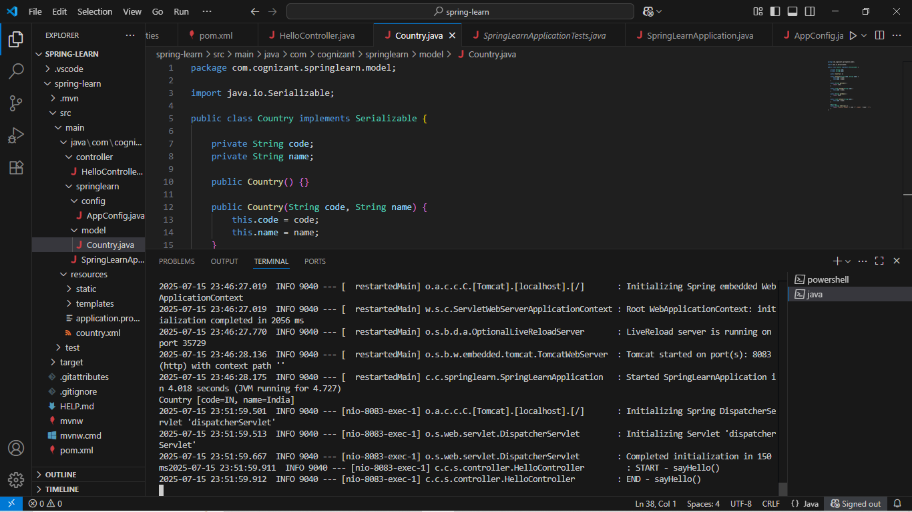

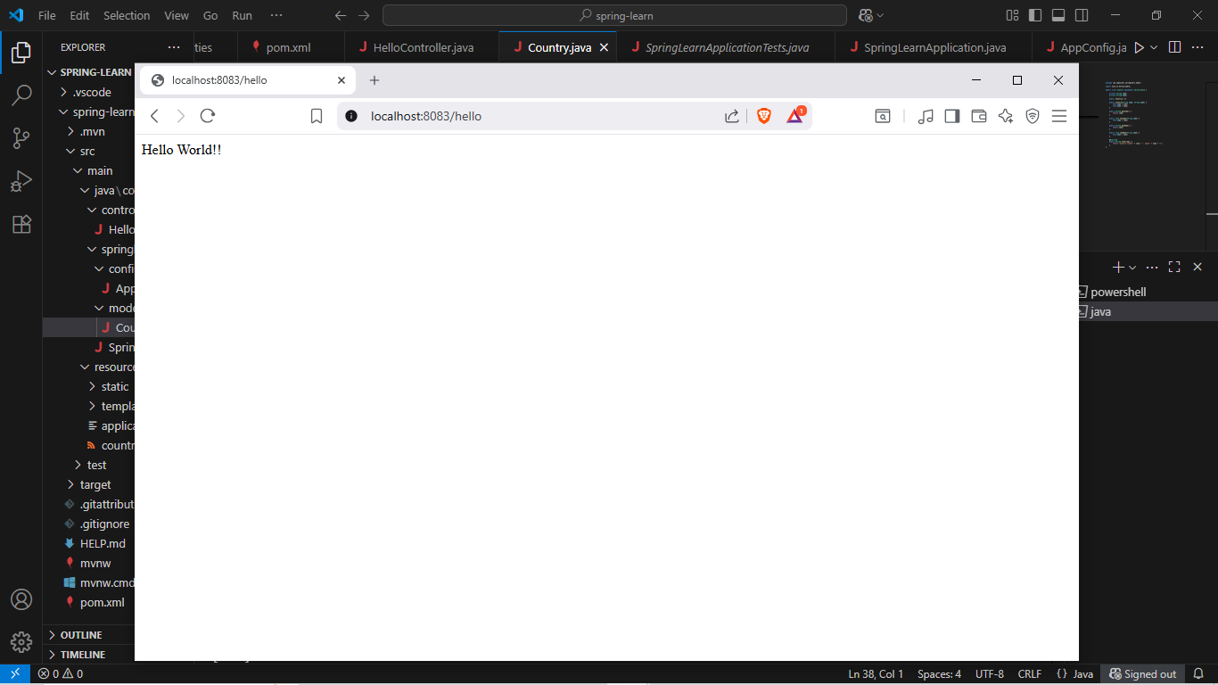

**4.REST - Country Web Service:**

**Code:**

**Country.xml:**

<?xml version="1.0" encoding="UTF-8"?>

<beans xmlns="http://www.springframework.org/schema/beans"

xmlns:xsi="http://www.w3.org/2001/XMLSchema-instance"

xsi:schemaLocation="http://www.springframework.org/schema/beans

https://www.springframework.org/schema/beans/spring-beans.xsd">

<bean id="country" class="com.cognizant.springlearn.model.Country">

<property name="code" value="IN"/>

<property name="name" value="India"/>

</bean>

</beans>

**Country.java:**

package com.cognizant.springlearn.model;

import java.io.Serializable;

public class Country implements Serializable {

private String code;

private String name;

public Country() {}

public Country(String code, String name) {

this.code = code;

this.name = name;

}

public String getCode() {

return code;

}

public void setCode(String code) {

this.code = code;

}

public String getName() {

return name;

}

public void setName(String name) {

this.name = name;

}

@Override

public String toString() {

return "Country [code=" + code + ", name=" + name + "]";

}

}

**CountryController.java:**

package com.cognizant.springlearn.controller;

import com.cognizant.springlearn.model.Country;

import org.slf4j.Logger;

import org.slf4j.LoggerFactory;

import org.springframework.context.ApplicationContext;

import org.springframework.context.support.ClassPathXmlApplicationContext;

import org.springframework.web.bind.annotation.RequestMapping;

import org.springframework.web.bind.annotation.RestController;

@RestController

public class CountryController {

private static final Logger LOGGER = LoggerFactory.getLogger(CountryController.class);

@RequestMapping("/country")

public Country getCountryIndia() {

LOGGER.info("START - getCountryIndia");

ApplicationContext context = new ClassPathXmlApplicationContext("country.xml");

Country country = (Country) context.getBean("country");

LOGGER.info("END - getCountryIndia");

return country;

}

}

**Output:**

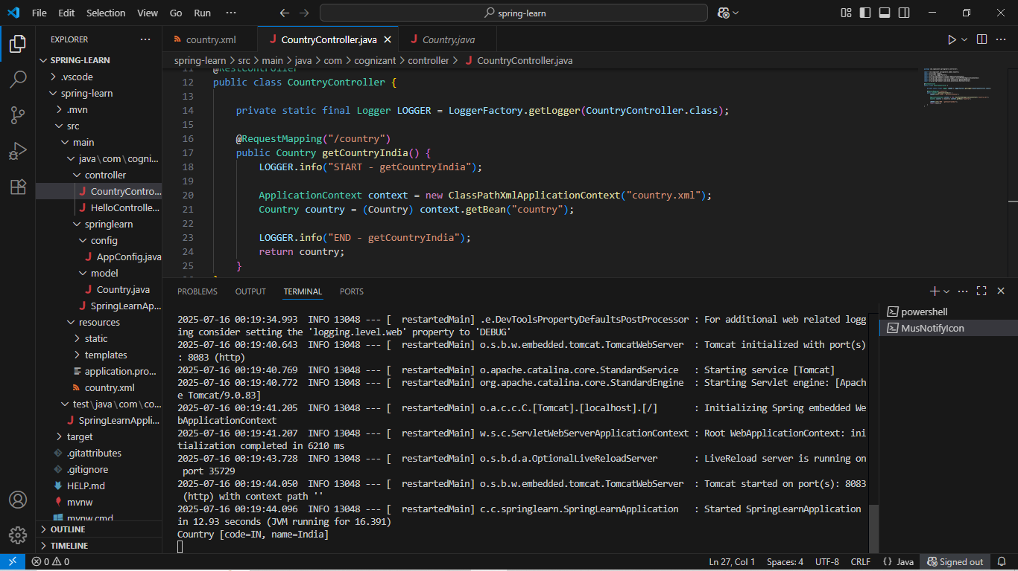

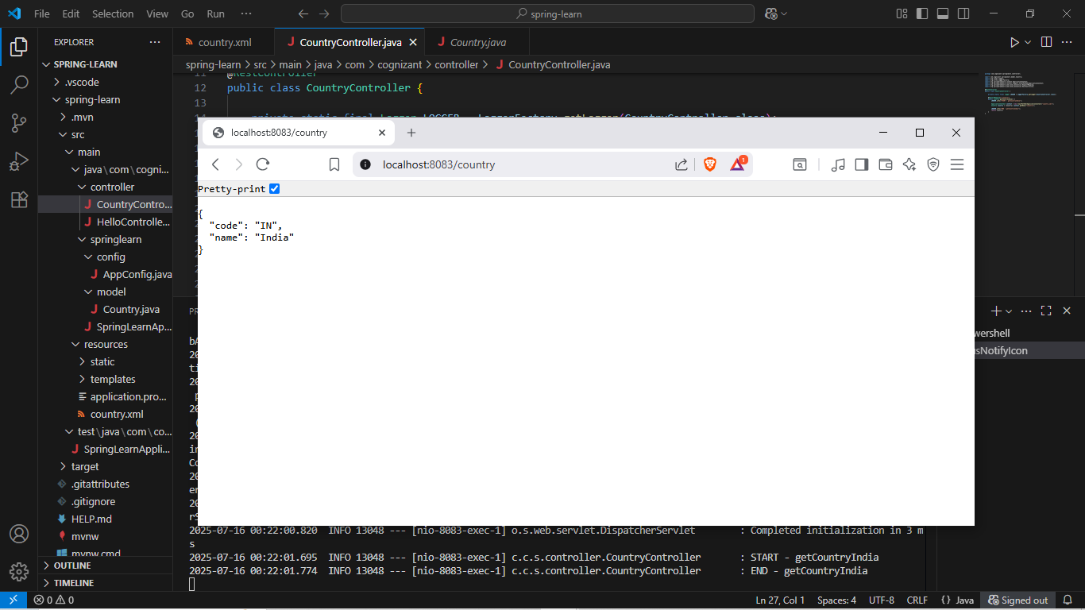

**5.REST - Get country based on country code:**

**Code:**

**Country.xml:**

<beans xmlns="http://www.springframework.org/schema/beans"

xmlns:xsi="http://www.w3.org/2001/XMLSchema-instance"

xsi:schemaLocation="http://www.springframework.org/schema/beans

http://www.springframework.org/schema/beans/spring-beans.xsd">

<bean id="country" class="com.cognizant.springlearn.model.Country">

<property name="code" value="IN" />

<property name="name" value="India" />

</bean>

<bean id="countryList" class="java.util.ArrayList">

<constructor-arg>

<list>

<ref bean="country" />

<bean class="com.cognizant.springlearn.model.Country">

<property name="code" value="US" />

<property name="name" value="United States" />

</bean>

<bean class="com.cognizant.springlearn.model.Country">

<property name="code" value="CN" />

<property name="name" value="China" />

</bean>

</list>

</constructor-arg>

</bean>

</beans>

**CountryService.java:**

package com.cognizant.springlearn.service;

import com.cognizant.springlearn.model.Country;

import org.springframework.stereotype.Service;

import org.springframework.context.support.ClassPathXmlApplicationContext;

import java.util.List;

@Service

public class CountryService {

public Country getCountry(String code) {

ClassPathXmlApplicationContext context = new ClassPathXmlApplicationContext("country.xml");

List<Country> countries = context.getBean("countryList", List.class);

return countries.stream()

.filter(c -> c.getCode().equalsIgnoreCase(code))

.findFirst()

.orElse(null); // or throw new CountryNotFoundException()

}

}

**CountryController.java:**

package com.cognizant.springlearn.controller;

import com.cognizant.springlearn.model.Country;

import com.cognizant.springlearn.service.CountryService;

import org.slf4j.Logger;

import org.slf4j.LoggerFactory;

import org.springframework.web.bind.annotation.*;

@RestController

public class CountryController {

private final CountryService countryService;

private static final Logger LOGGER = LoggerFactory.getLogger(CountryController.class);

public CountryController(CountryService countryService) {

this.countryService = countryService;

}

@GetMapping("/countries/{code}")

public Country getCountry(@PathVariable String code) {

LOGGER.info("START getCountry()");

Country country = countryService.getCountry(code);

LOGGER.info("END getCountry()");

return country;

}

}

**Output:**

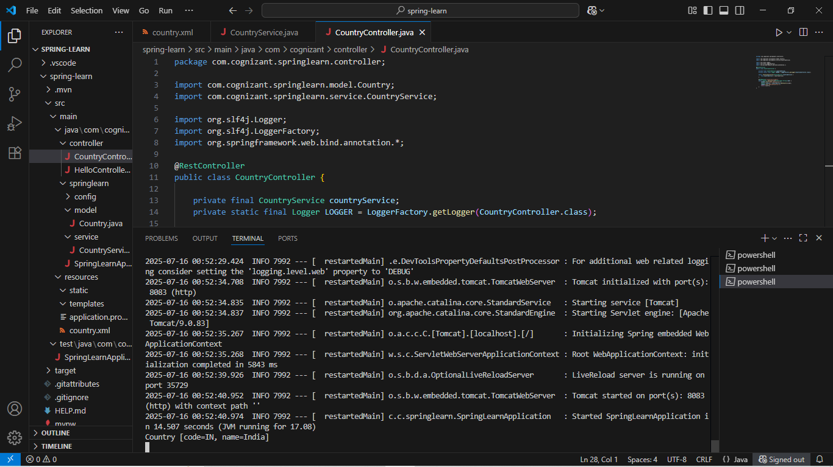

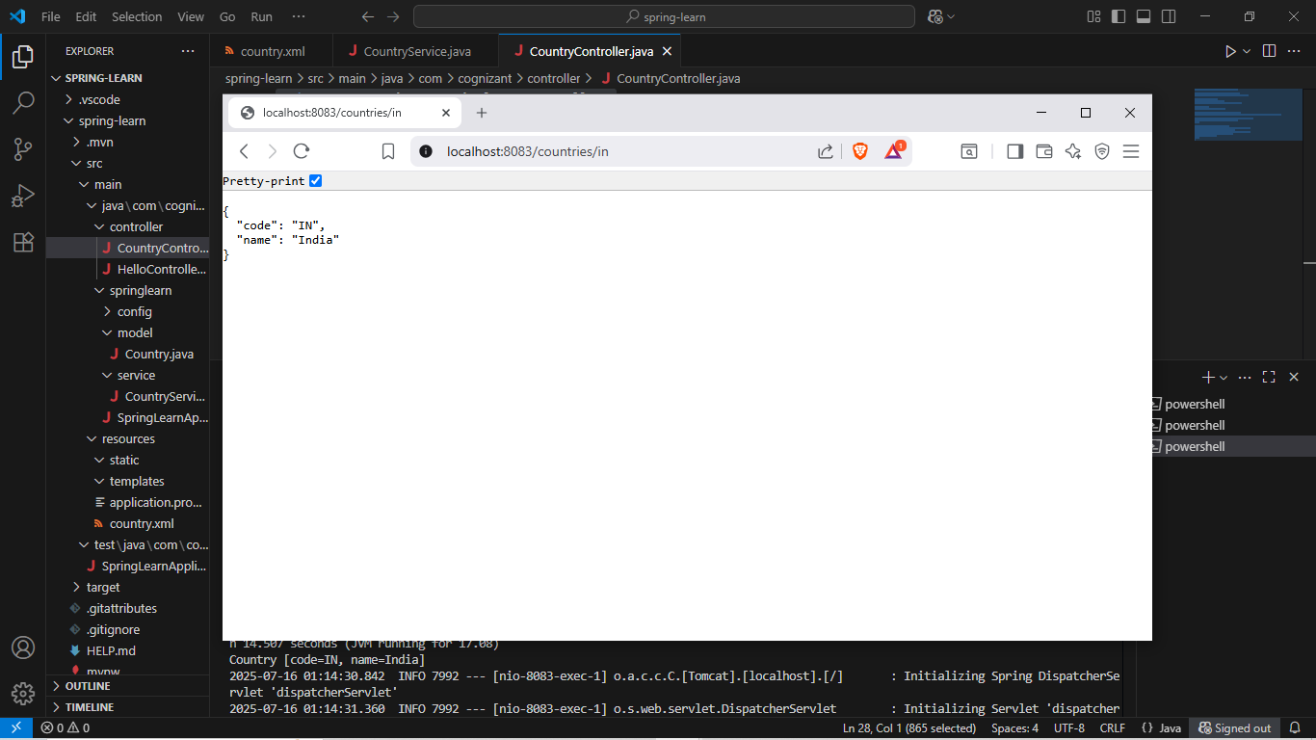

**6. Create authentication service that returns JWT:**

**Code:**

**AuthenticationController.java:**

package com.example.springlearn.controller;

import com.example.springlearn.util.JwtUtil;

import org.springframework.beans.factory.annotation.Autowired;

import org.springframework.http.ResponseEntity;

import org.springframework.web.bind.annotation.*;

import jakarta.servlet.http.HttpServletRequest;

import java.util.Base64;

@RestController

public class AuthenticationController {

@Autowired

private JwtUtil jwtUtil;

@GetMapping("/authenticate")

public ResponseEntity<?> authenticate(HttpServletRequest request) {

String authHeader = request.getHeader("Authorization");

if (authHeader == null || !authHeader.startsWith("Basic ")) {

return ResponseEntity.status(401).body("Missing or invalid Authorization header");

}

String base64Credentials = authHeader.substring("Basic ".length());

byte[] decodedBytes = Base64.getDecoder().decode(base64Credentials);

String credentials = new String(decodedBytes);

String[] parts = credentials.split(":", 2);

String username = parts[0];

String password = parts[1];

if ("user".equals(username) && "pwd".equals(password)) {

String token = jwtUtil.generateToken(username);

return ResponseEntity.ok("{\"token\":\"" + token + "\"}");

} else {

return ResponseEntity.status(403).body("Invalid credentials");

}

}

}

**SecurityConfig.java:**

package com.example.springlearn.config;

import org.springframework.context.annotation.Bean;

import org.springframework.context.annotation.Configuration;

import org.springframework.security.config.Customizer;

import org.springframework.security.config.annotation.web.builders.HttpSecurity;

import org.springframework.security.core.userdetails.User;

import org.springframework.security.core.userdetails.UserDetails;

import org.springframework.security.core.userdetails.UserDetailsService;

import org.springframework.security.crypto.bcrypt.BCryptPasswordEncoder;

import org.springframework.security.crypto.password.PasswordEncoder;

import org.springframework.security.provisioning.InMemoryUserDetailsManager;

import org.springframework.security.web.SecurityFilterChain;

@Configuration

public class SecurityConfig {

@Bean

public SecurityFilterChain filterChain(HttpSecurity http) throws Exception {

http.csrf(csrf -> csrf.disable())

.authorizeHttpRequests(auth -> auth

.requestMatchers("/authenticate").authenticated()

.anyRequest().permitAll())

.httpBasic(Customizer.withDefaults());

return http.build();

}

@Bean

public UserDetailsService userDetailsService() {

UserDetails user = User.builder()

.username("user")

.password(passwordEncoder().encode("pwd"))

.roles("USER")

.build();

return new InMemoryUserDetailsManager(user);

}

@Bean

public PasswordEncoder passwordEncoder() {

return new BCryptPasswordEncoder();

}

}

**JwtUtil.java:**

package com.example.springlearn.util;

import io.jsonwebtoken.Jwts;

import io.jsonwebtoken.SignatureAlgorithm;

import io.jsonwebtoken.security.Keys;

import org.springframework.stereotype.Component;

import javax.crypto.SecretKey;

import java.util.Date;

@Component public class JwtUtil {

private final SecretKey secretKey = Keys.secretKeyFor(SignatureAlgorithm.HS256);

private final long validity = 3600000; // 1 hour

public String generateToken(String username) {  
 return Jwts.builder()  
 .setSubject(username)  
 .setIssuedAt(new Date())  
 .setExpiration(new Date(System.currentTimeMillis() + validity))  
 .signWith(secretKey)  
 .compact();  
 }

}

**SpringLearnApplication.java:**

package com.example.springlearn;

import org.springframework.boot.SpringApplication;

import org.springframework.boot.autoconfigure.SpringBootApplication;

@SpringBootApplication

public class SpringLearnApplication {

public static void main(String[] args) {

SpringApplication.run(SpringLearnApplication.class, args);

}

}

**application.properties:**

server.port=8095

**pom.xml:**

<project xmlns="http://maven.apache.org/POM/4.0.0"

xmlns:xsi="http://www.w3.org/2001/XMLSchema-instance"

xsi:schemaLocation="http://maven.apache.org/POM/4.0.0

<http://maven.apache.org/xsd/maven-4.0.0.xsd>">

<modelVersion>4.0.0</modelVersion>

<parent>

<groupId>org.springframework.boot</groupId>

<artifactId>spring-boot-starter-parent</artifactId>

<version>3.1.3</version>

<relativePath/>

</parent>

<groupId>com.example</groupId>

<artifactId>spring-learn-jwt</artifactId>

<version>1.0.0</version>

<packaging>jar</packaging>

<properties>

<java.version>17</java.version>

</properties>

<dependencies>

<dependency>

<groupId>org.springframework.boot</groupId>

<artifactId>spring-boot-starter-web</artifactId>

</dependency>

<dependency>

<groupId>org.springframework.boot</groupId>

<artifactId>spring-boot-starter-security</artifactId>

</dependency>

<dependency>

<groupId>io.jsonwebtoken</groupId>

<artifactId>jjwt-api</artifactId>

<version>0.11.5</version>

</dependency>

<dependency>

<groupId>io.jsonwebtoken</groupId>

<artifactId>jjwt-impl</artifactId>

<version>0.11.5</version>

<scope>runtime</scope>

</dependency>

<dependency>

<groupId>io.jsonwebtoken</groupId>

<artifactId>jjwt-jackson</artifactId>

<version>0.11.5</version>

<scope>runtime</scope>

</dependency>

</dependencies>

<build>

<plugins>

<plugin>

<groupId>org.springframework.boot</groupId>

<artifactId>spring-boot-maven-plugin</artifactId>

</plugin>

</plugins>

</build>

</project>

**Output:**

